6 Reasons Why Should School Districts Pass No Idling Resolutions

The research is clear. Air pollution is deadly, poisoning our air, harming children and people with preexisting conditions and threatening our water and food supply, bees, animals, and our environment. A simple way to reduce air pollution, save lives, protect children’s health, public safety and the environment is for drivers to turn off their car engines (instead of idling) when they are parked. Idling is leaving your car engine running, when the car is parked. Car exhaust is full of deadly toxic chemicals. In fact, 1 minute of idling has more carbon monoxide than 3 packs of cigarettes (“Air Quality Criteria for Carbon Monoxide”). Most school parking lots are full of cars idling, pumping out dangerous toxic car exhaust into the faces of children; therefore, to protect the health of children, teachers, staff, parents and the community, school districts must pass a No Idling Resolution that includes posting No Idling signs (to remind drivers to turn off their engines when they are parked and waiting), and educational information for parents, students and the community to understand that car exhaust is toxic and dangerous.

1. Car exhaust is toxic and contains carbon monoxide, nitrogen oxide, hydrocarbons, sulfur dioxide, formaldehyde, VOCs, particulate matter, acetaldehyde, and benzene, which can cause cancer, lung and heart conditions, neurological disorders and death (“How Mobile Source Pollution Affects Your Health”). When fuel is burned by a car or truck engine, deadly gases, vapor and particulate matter come out of the tailpipe. We have all seen the tailpipes of cars, covered in toxic black soot, but most of the deadly gases coming out of the tailpipes of cars, like carbon monoxide, formaldehyde and others, cannot be seen. In addition to poisonous gases coming out of the tailpipes of idling cars, tiny microscopic particles, smaller than the width of a piece of hair, called particulate matter or PMs can get trapped in our lungs and tissues and can make us very sick. The smaller the size, of PMs, the more dangerous. PM 1.0 is smaller and more dangerous than PM 2.5 PMs, PM 10. We can prevent toxic air pollution from car exhaust by not idling! Drivers should turn their cars off when they are parked in a parking lot or waiting to pick someone up.

2. Air pollution and car exhaust from idling is hazardous to children’s health. Air pollution can cause death, heart and lung diseases and asthma, making breathing difficult. No child should have to gasp or struggle to get air. The CDC, Center for Disease Control has conducted many studies and found that Asthma is the 3rd leading cause of hospitalization for children under 15, Additionally, each day, approximately 38,000 children in the United States are absent from school because of asthma. This means that there are over 13.8 million school days lost in the United States lost in each year. Also, every year over 330,000 children in the U.S. and 4 million children in the world are diagnosed with asthma (“Global, National and Urban Burdens”).
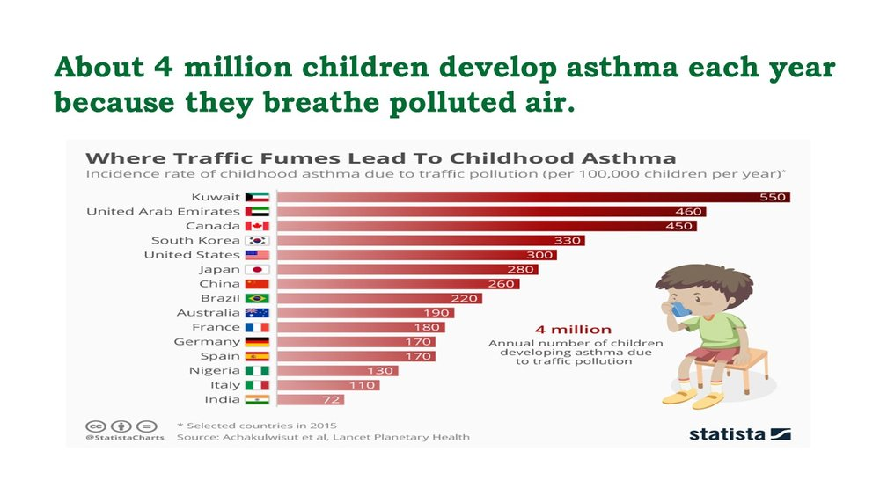
Breathing problems affect every aspect of life, causing huge amounts stress, problems at home, school and on the field or playground. Scientist and author of the “Idling at Schools Newsletter,” Washtenaw.org, explains that air pollution can cause a child’s lungs to not grow properly and also states:
Some studies even show exposure to these pollutants is associated
with low-birth-weight babies. Also, chemical reactions between
exhaust emissions has been associated with eye, nose and throat
irritation and, in higher concentrations, asthma, bronchitis, increased
susceptibility to respiratory infections, and decreased lung function.
Asthma is the most common chronic medical condition among children…

The evidence is clear; breathing car exhaust from idling cars is hazardous to children’s health. Something must be done to reduce air pollution, car exhaust and idling! Schools must educate parents, students and community members of the dangers of idling. Children’s lives are at stake and depending on the actions taken by school districts.

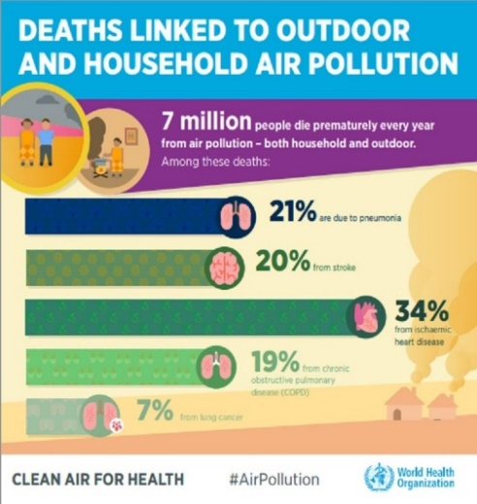
3. Air pollution is especially harmful to people with preexisting conditions such a cancer, heart and lung problems, diabetes and other conditions. The World Health Organization estimates that about 7 million premature deaths were caused in the world, each year in because of air pollution (“Mortality and Burden of Disease”).

Poor air quality is toxic and air pollution and car exhaust from idling are even worse for people that are already sick. “Idling and exposure to traffic-related air pollutants has been directly linked to allergies, asthma and other respiratory diseases, to heart and cardiovascular diseases, and to cancer,” (“Idling Hurts Young Lungs”). So, when parked cars idle and emit dangerous car exhaust it endangers healthy children at school and students, teachers, principals, parents and family members who are already fighting to be healthy.

Why isn’t there information, education or No Idling signs at schools to protect students, teachers, staff, parents and the community? Why is it that twice a day, most children must walk through deadly air pollution from long lines and parking lots full of idling cars? Who is going to let drivers know that if they are going to be parked for more than 5-10 seconds, they cans simply turn off their engines and save lives? School districts must provide information, education and NO Idling signs to let people know the dangers of car exhaust from idling. Every day children are being harmed and most schools are not acknowledging the problem or even working towards solutions.

Obviously, in cases of an emergency, extreme temperatures or the need to operate equipment for a disability, a driver may idle for a minute until they can turn off their engines, move their car or park. But, people need to remember that they are putting themselves in danger when they are breathing car exhaust. It is better to go inside and wait, than sit in a car that is idling. People who sit in cars that idle are putting themselves and their families at risk of poisoning. Even new cars can have tiny leaks or cracks in the exhaust system, allowing poisonous gases to come into the car. If the car is parked and idling, this is especially deadly.

Information is needed! Some people do not know even know that idling is bad for engines. Car engines were built to drive, not sit and idle. The “Summary of OEM Idling Recommendations from Vehicle Owner’s Manuals,” explains that idling hurts the engine of a car. If a car is going to be parked for more than 5 to 10 seconds, turn it off!

4. Air pollution is harmful to bees, insects, birds and animals that pollinate our plants and crops that are needed for our food supply, and keep our environment in balance. Animals and fish are being poisoned. Bees are dying. Car exhaust harms animals, birds and insects, which directly affects our food supply. “Exposure to air pollution, particulate matter [PMs] from traffic vehicles is hazardous to the vascular system (system of veins) in animals,” (Moller). Clearly, we must do all we can to reduce air pollution. Passing a No Idling Resolution at schools will protect not only children’s health, and is a step to protecting wildlife and our food supply.

5. Idling and car exhaust in the US produce 30 million tons of carbon dioxide, CO2, and other Greenhouse gases that are bad for the environment and contribute to global warming and climate change (“Idling Reduction for Personal Vehicles”). Greenhouse gases, like carbon dioxide, trap heat and cause more and more heat over time. Each gallon of gas burned puts 20 pounds of carbon dioxide in the atmosphere. Every day, the US wastes over 200,000 barrels of foreign oil because of people idling, sitting in their cars while they are parked (“The Truth About Idling”). Approximately 27% of Greenhouse gases in the U.S. are from transportation.

Although New York City has a public transportation system and a majority of people take the subway, in New York City alone, idling cars and trucks produce 130,000 tons of carbon dioxide each year. To offset this amount of global warming pollution, drivers would need to either stop idling the average 16 minutes per day when they are parked, or plant over 22. 7 square miles with trees each year (“Attention Drivers Turn Off Your Idling Engines”).

The graph, “It’s Official: Atmospheric CO2, just exceeded 415 PPM for the First Time in Human History,” shows that carbon dioxide is rising quickly since the Industrial Revolution and the burning of fossil fuels. More and more cars are on the roads, producing more and more carbon dioxide and Greenhouse gases.

It’s Official: Atmospheric CO2, Just Exceeded 415 PPM for the First Time in Human History
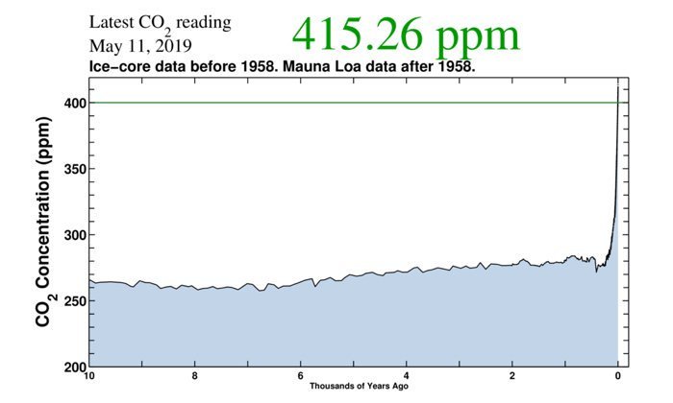
Additionally, in 2009, the EPA, Environmental Protection Agency, released its scientific findings, known as the “Endangerment Finding,” concluding that “global warming emissions presented a danger to public health” and found that pollution and global warming is connected with:
- hotter, longer heat waves that threaten the health of the sick, poor, and elderly;
- increases in ground-level ozone pollution, linked to asthma and other respiratory illnesses; and
- extreme weather events that can lead to deaths, injuries, and stress-related illnesses (“How Mobile Source Pollution Affects Your Health”).
The EPA has been required to reduce global warming emissions under the Clean Air Act because air pollution and car exhaust endangers public health. The future of the Clean Air Act in the United States is uncertain as the Trump Administration has removed approximately 80 protections for clean air and clean water and is currently trying to pull the United States out of the Paris Agreement, signed in 2018 by 195 countries that commit to measure, plan and regularly report their actions and contributions to fighting global warming (“Ratification Tracker”).

Many cities around the world have pledged to use renewable energy and have committed to reduce the burning of fossil fuels to protect health and the environment. School districts have a duty to protect children’s health and their environment. Passing a No Idling Resolution with No Idling signs and education is a step that school districts must take to protect students and their environment.

6. It is the job of school district to create and pass policies that protect children’s health at school and help prepare them to be healthy adults. School districts across the country and world need to follow the example of VUSD (Vista Unified School District in Vista, California) that passed a No Idling Resolution in May of 2019. The VUSD No Idling Resolution improved on the State of California’s No Idling Resolution, ACR 160 that passed in 2015-2016, because the VUSD No Idling Resolution calls for action: No Idling signs and educational programs to reduce air pollution from car exhaust and bring awareness to the problem (“No Idling Resolution for Schools”).

According to Elena Craft, PhD, in her article, “No Idling Resolution, State and Local Programs Cut Vehicle Emissions” the seriousness and proof of the “adverse neurodevelopmental effects of exposure to combustion-related air pollution,” makes it important to put policies forward, “strengthening federal environmental health protections, advancing state and local actions, and supporting scientific research to inform effective strategies for reducing children's exposures to combustion-related air pollution.” Craft calls for No Idling Resolutions and gives three ways policies can protect children’s health:
- to improve children's neurological development;
- to improve other health problems; and,
- to work on climate change.

So, if idling is so dangerous for people and the planet, why haven’t adults done something about it? Why doesn’t every school have a No Idling Resolution, like VUSD? Often people do not think about what they cannot see. Since most poisonous gases and particulate matter cannot be seen easily, people mistakenly think that the air is safe. Car exhaust is a real and present danger every single day that threaten most students in the United States and around the world. It is the responsibility of school districts to create policies and educate teachers, staff and students that keep kids safe on school property. Most people don’t realize that air pollution from the car exhaust from idling cars is deadly.

Some people will say that wealthier school districts do not need a No Idling Resolution because many drivers have electric cars. While it is true that electric cars do not produce toxic car exhaust, not everyone in the district can afford an electric car. Also, for people who need to buy a van, there are not any all electric vans available in the United States, like there are in Japan and Europe. Although two congressmen (California Representative, Mike Levin and Jeff Merkley of Oregon) are working to increase the number of electric cars by requiring 50% of vehicles sold in the US to be electric, it will take many years for more electric vehicles to be on the roads, and this bill, called the the bill, the Zero Emission Vehicles Act of 2019, has very little chance of passing (Levin). The problem of toxic air pollution is a problem now that must be addressed. Most children must pass by rows of parked cars that are idling and spewing out deadly toxins from the tailpipe. Something must be done now!

In conclusion, school districts must pass a No Idling Resolution to protect students, teachers, staff, parents, the community and the environment. Education is needed. We must take action now to protect our most vulnerable- our children and those with a pre-existing condition. We must pass No Idling Resolutions in school districts that includes signs and education so that drivers turn off their engines and kids can learn the facts and spread the word: car exhaust is toxic. Stay away!

Works Cited
“Air Quality Criteria for Carbon Monoxide (Final Report, 2000).” EPA,
Environmental Protection Agency, 9 Mar. 2017,
cfpub.epa.gov/ncea/risk/recordisplay.cfm?deid=18163.

Ashish. “Why Are Vehicle Exhaust Fumes Harmful to Humans.”
ScienceABC.com. 2017, scienceabc.com/humans/why-are-vehicles-exhaust
fumes-harmful-to-humans.html

“Asthma-Related Missed School Days among Children Aged 5–17 Years.”
Centers for Disease Control and Prevention, 5 Oct 2015,
cdc.gov/asthma/asthma_stats/missing_days.htm.

“Attention Drivers, Turn off Your Idling Engines.” Environmental Defense
Fund. 2009, edf.org/attention-drivers-turn-your-idling-engines.

“Bill Text - ACR-160 Motor Vehicle Idling: Children”. State of California,
leginfo.legislature.ca.gov/faces/billTextClient.xhtml?bill_id=
201520160ACR10.

“Breathe Easy Anti-Idling Campaign.” BreatheEasy, City of Fort Collins,
fcgov.com/airquality/breathe-easy.

Craft, Elena. “No Idling Resolution: State And Local Programs Cut Vehicle
Emissions & Costs At The Pump.” Texas Clean Air Matters, 31 July 2012,
blogs.edf.org/texascleanairmatters/2012/07/31/no-idling-resolution-state
and-local-programs-cut-vehicle-emissions-costs-at-the-pump/.

Dockrill, Peter. “It's Official: Atmospheric CO2 Just Exceeded 415 Ppm For The
First Time in Human History.” ScienceAlert, 13 May 2019,
sciencealert.com/it-s-official-atmospheric-co2-just-exceeded-415-ppm-for
first-time-in-human-history.

Essick, Peter. “Air Pollution Causes, Effects, and Solutions.” Air Pollution,
Facts and Information, 25 Feb. 2019,
nationalgeographic.com/environment/global-warming/pollution/.

“Global, National, and Urban Burdens of Paediatric Asthma Incidence
Attributable to Ambient NO2 Pollution: Estimates from Global Datasets.”
The Lancet Planetary Health, Elsevier, 11 Apr. 2019,
sciencedirect.com/science/article/pii/S2542519619300464?via=ihub.

“Healthy Air, Healthy Brains: Advancing Air Pollution Policy to Protect
Children’s Health.” American Public Health Association (APHA)
Publications, 13 Mar. 2019,
ajph.aphapublications.org/doi/full/10.2105/AJPH.2018.304902.

Hooper, Laura G. “Ambient Air Pollution and Clinical Implications for
Susceptible Populations.” Annals of the American Thoracic Society, 16 Nov.
2017, atsjournals.org/doi/full/10.1513/AnnalsATS.201707-574MG.

“How Mobile Source Pollution Affects Your Health.” EPA, Environmental
Protection Agency, 15 Dec. 2016, epa.gov/mobile-source-pollution/how
mobile-source-pollution-affects-your-health.

“Idling Hurts Young Lungs.” Washtenaw County Michigan,
washtenaw.org/DocumentCenter/View/2963/Information-Idling-at-Schools
for-Newsletter-PDF?bidId=.

“Idling Reduction for Personal Vehicles.” US Dept of Energy, May 2015,
afdc.energy.gov/files/u/publication/idling_personal_vehicles.pdf.

Keel-Blackmon, Kristy, et al. Summary of OEM Idling Recommendations from Vehicle Owner’s
Manuals. Oak Ridge National Laboratory, June 2016,
info.ornl.gov/sites/publications/files/Pub61263.pdf.

Leonard RJ, Vergoz V, Proschogo N, McArthur C, Hochuli DF (2019) “Petrol
exhaust pollution impairs honey bee learning and memory”. Oikos 128(2):
264-273. doi.org/10.1111/oik.05405

Levin, Mike. “Representative Levin, Senator Merkley Introduce Major
Legislation to Transition America to 100% Zero-Emission Vehicles.”
Representative Mike Levin, 15 May 2019, mikelevin.house.gov/media/press
releases/representative-levin-senator-merkley-introduce-major-legislation
transition.

Møller, Peter, et al. “Atherosclerosis and Vasomotor Dysfunction in Arteries of
Animals after Exposure to Combustion-Derived Particulate Matter or
Nanomaterials.” Critical Reviews in Toxicology, U.S. National Library of
Medicine, 2016, ncbi.nlm.nih.gov/pubmed/27028752.

“Mortality and Burden of Disease from Ambient Air Pollution.” World Health
Organization, World Health Organization, 27 Dec. 2018,
who.int/gho/phe/outdoor_air_pollution/burden/en/.

“No-Idling Resolution for Schools.” Vista Unified School District,
cleanearth4kids.org/s/Vista-No-Idling-Resolution-19-38.pdf.

“Ratification Tracker.” Ratification Tracker / Climate Analytics,
climateanalytics.org/briefings/ratification-tracker/.

Rollins, Katharina. Engine Idling around Schools and the Effect It Has on
Children's Health. New York Amsterdam News. 2/19/2009, Vol. 100 Issue 8,
p6-6.

“The Truth About Idling.” Sustainable America,
sustainableamerica.org/blog/the-truth-about-idling-infographic/.

“Why Is Idling Harmful?” North Carolina Department of Environmental
Quality, deq.nc.gov/about/divisions/air-quality/motor-vehicles-air
quality/idle-reduction/why-idling-harmful.

