No Idling Pledge, A Solution for Pollution
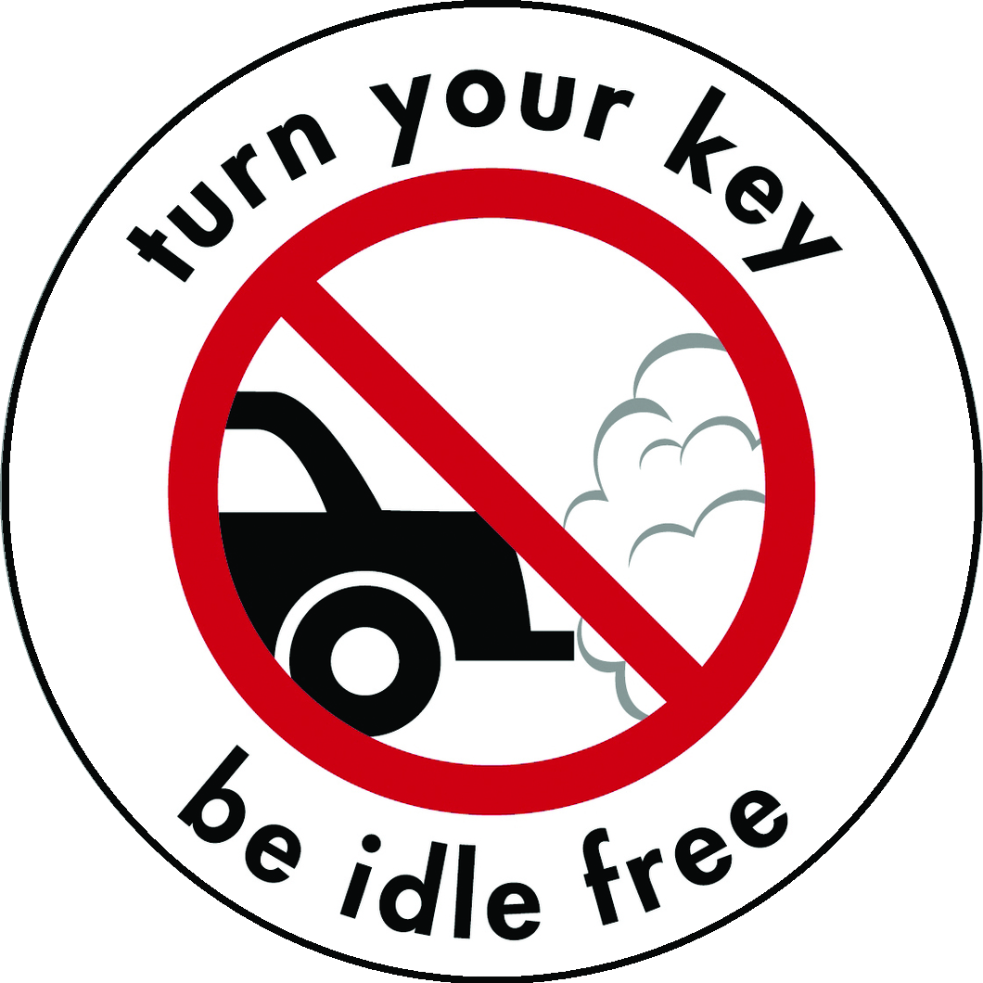

I care about the health of children, public safety and clean air.
I will turn my engine off
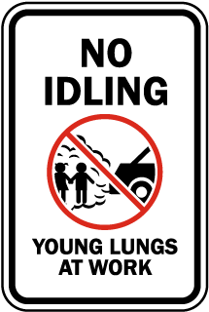
when I am parked in a parking lot
or waiting to pick someone up
and
avoid drive-throughs and lines when possible.
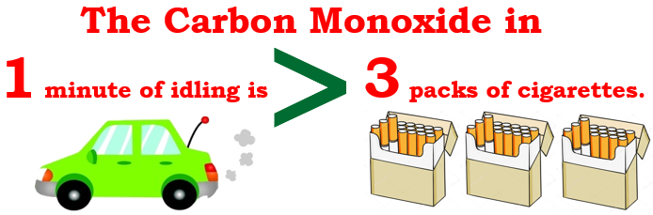
*Exceptions: emergencies, extreme weather, operating equipment for a disability.
I will never turn my engine off at a stop light or a stop sign.
Signed: ________________________________ Date: ____________
No Idling Pledge, A Solution for Pollution

I care about the health of children, public safety and clean air.
I will turn my engine off
when I am parked in a parking lot
or waiting to pick someone up
and
avoid drive-throughs and lines when possible.
*Exceptions: emergencies, extreme weather, operating equipment for a disability.
I will never turn my engine off at a stop light or a stop sign.
Signed: ________________________________ Date: ____________

